- DUE TODAY APRIL 18 (in 3 hours)
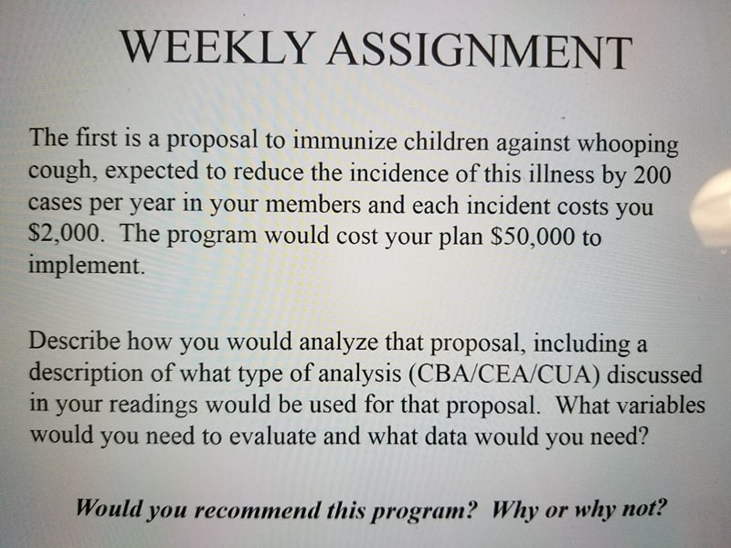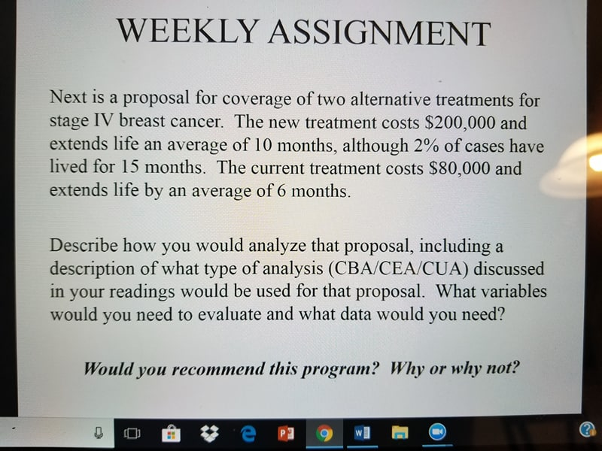

- DUE TODAY APRIL 18 (in 3 hours)
I just need you to redo the calculations in the excel sheet on another excel sheet just copy paste the numbers, but I need to see calculations on excel. Then finish up and calculate the cash flows, payback,…. Answer the questions asked below.
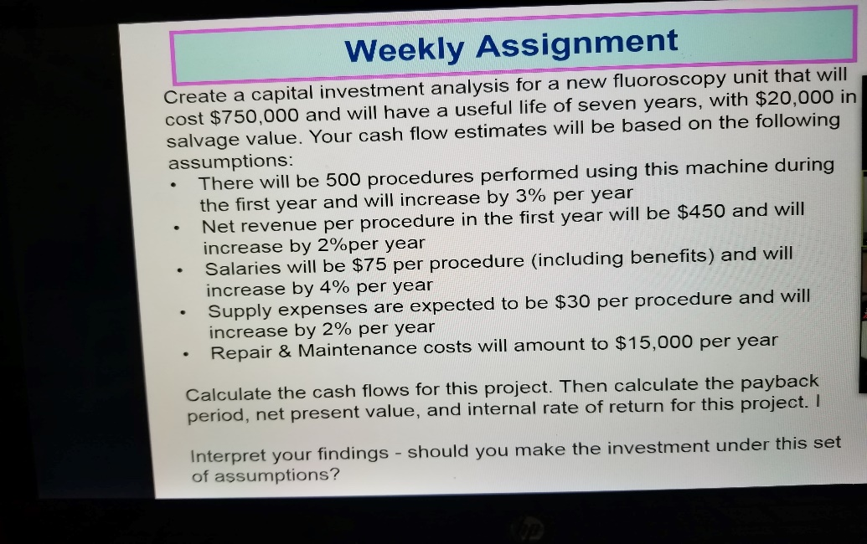
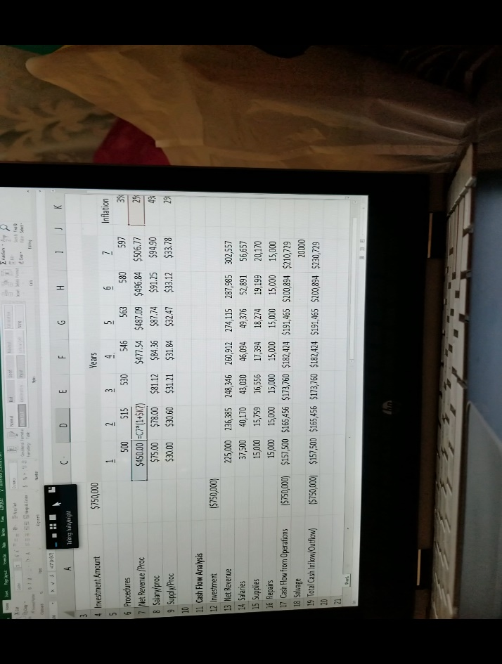

- DUE FRIDAY APRIL 20
In an Excel spreadsheet, you will create a capital investment analysis for a new digital ultrasound machine. The machine will cost $170,000 and will have a useful life of five years, with $8,000 in salvage value at the end of the fifth year. Your cash flow estimates will be based on the following assumptions:
- There will be 750 procedures performed using this machine during the first year and will increase by 2% per year
- Net revenue per procedure in the first year will be $140 and will increase by 3%per year
- Salaries will be $55 per procedure (including benefits) and will increase by 2.5% per year
- Supply expenses are expected to be $20 per procedure and will increase by 3% per year
- Repair & Maintenance costs will amount to $5,000 per year after the first year. There are no repair costs expected the first year of the project
After calculating the cash flows for this project, calculate the payback period, net present value, and internal rate of return for this project and then interpret your findings - should you make the investment under this set of assumptions?
- DUE FRIDAY APRIL 20
In a short essay of 2-3 paragraphs differentiate between cost-effectiveness analysis and benefit-
cost analysis. Also identify any areas you need additional information or clarification on.

